Pr3+:YLF laser is solid-state laser with a gain-line shape corresponds to Lorentzian profile which belongs to homogeneous broadening [2016, Li Qing-Song]. The gain coefficient can be expressed as [wolfram]

 (1)

where  is the central frequency and  is full width at half-maximum of the laser gain-line shape.

By introducing a frequency shift of the Stark splitting By introducing , the frequency shift of the Stark splitting from the unperturbed frequency induced by the intra-cavity laser field, Eq. (1) can be written as

(2)

According to the rough self-mode-locking criterion for solid-state lasers [1992, Zhijiang Wang], self-mode-locking pulses can occur when 

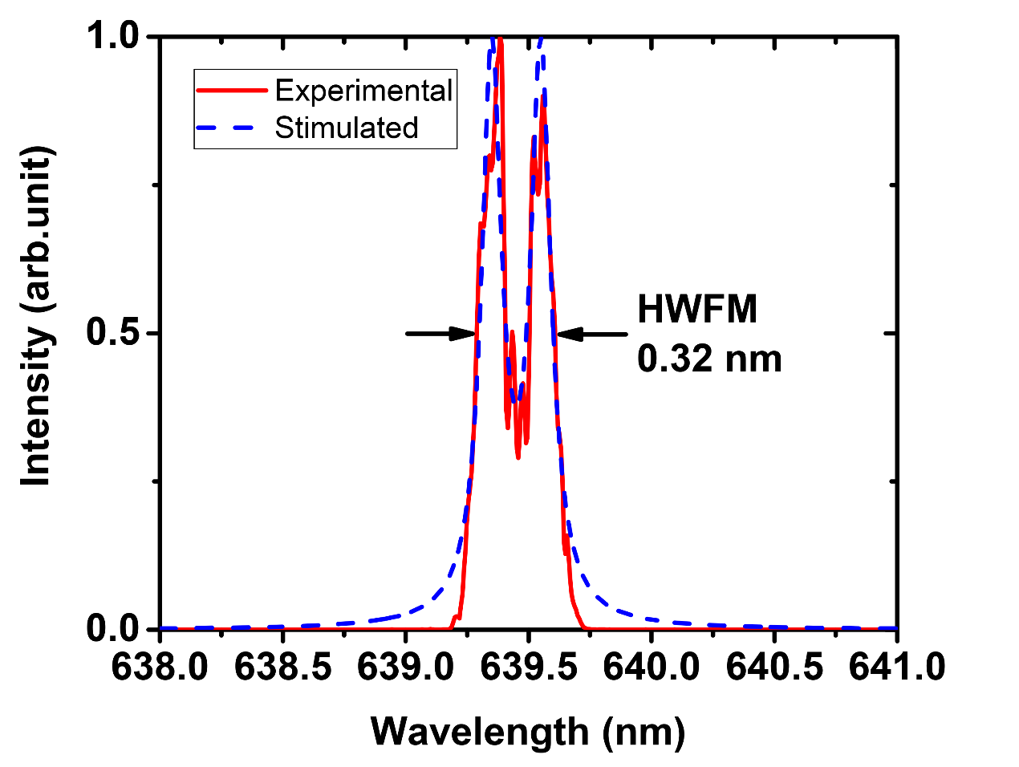

As is recorded in Fig. 10, the stark splitting gain-line shape

Coincides well with

The subtle difference between the stimulated stark splitting gain-line shape shown as the blue-dashed line and the measured spectral shape of output pulses depicted as the red line might be attributed to the fact that stark effect should be considered dynamically, thus forming a gain-line shape with several dips.

The pulse width of SML laser is supposed to be larger than that of

Because the

线宽窄，参与谐振的纵模数少，虽然容易锁模但是

[2016, Li Qing-Song]. “The effect of the depth of single longitudinal mode modulation in Q-switching pre-Pr3+:YLF laser”

[wolfram]. <http://scienceworld.wolfram.com/physics/LorentzianLineshape.html>

[1992, Zhijiang Wang]. “Novel self-mode-locking mechanism in narrow-band lasers”

[]